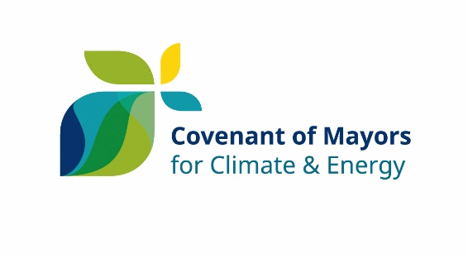
2030

I, [Name of the Mayor (or other equivalent representative)], [Mayor (or Job title)] of [Name of the local authority] have been mandated by the [Municipal Council (or equivalent decision-making body)] on [date] to sign up to the Covenant of Mayors for Climate and Energy, in full knowledge of the commitments set out in the official Commitment Document and summarised below.

Therefore, my local authority principally commits to:

- Reducing CO₂ (and possibly other greenhouse gas) emissions on its territory by at least 40% by 2030, namely through improved energy efficiency and greater use of renewable energy sources;
- Increasing its resilience by adapting to the impacts of climate change.

In order to translate these commitments into action, my local authority undertakes to fulfil the following step-by-step approach:

- Carry out a Baseline Emissions Inventory and a Climate Change Risk and Vulnerability Assessment;
- Submit a Sustainable Energy and Climate Action Plan within two years following the above date of the municipal council decision;
- Report progress at least every second year following the submission of the Sustainable Energy and Climate Action Plan for evaluation, monitoring and verification purposes.

I accept that my local authority shall be suspended from the initiative – subject to prior notice in writing by the Covenant of Mayors Office – in case of non-submission of the above-mentioned documents (i.e. Sustainable Energy and Climate Action Plan and Progress Reports) within the established deadlines.

[Name and complete address of the local authority]
[Name, e-mail and phone number of the contact person]

SIGNATURE

