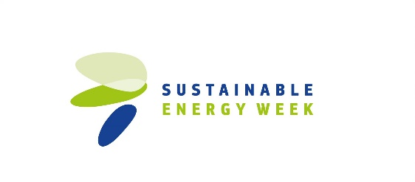
INSERT YOUR ORGANISATION’S LOGO HERE

News Announcement
[Organisation name] organises its [event name] event on [event date] as part of the EUSEW Energy Days
[Date of news announcement issuance]

[City, date]. [Organisation name] will organise its Energy Day event [event name] on [date] in [city] in the framework of the Energy Days of the EU Sustainable Energy Week (EUSEW).

The event will be focused on [information and objective of the event].
[Organisation] is excited to take part in the EUSEW Energy Days and [organisation/we] think it’s a great opportunity to bring [this/these activity/activities] to [citizens/our community].

[Paragraph about the event itself – venue, time, target audience, topics, format, link to registration page, registration deadline].

The event will be an opportunity to demonstrate why sustainable energy is important to citizens and businesses, and explore how to ‘shape Europe’s energy future’ by [adapt to the specific topic covered by the event].

Every year, hundreds of organisations and individuals participate in EUSEW. Partnering under the initiative is an opportunity to team up with EU countries, regions and communities to promote sustainable energy initiatives and the move towards renewables for clean, secure and efficient power.

All events that are part of #EUSEW19 #energydays will be published and promoted on the EUSEW website.

About EUSEW
Every year the European Commission (Directorate-General for Energy and Executive Agency for SMEs) organises the EU Sustainable Energy Week (EUSEW) – the biggest event dedicated to renewables and efficient energy use in Europe. This year’s theme is ‘Shaping Europe’s energy future’ and it covers four elements across the EU: the Policy Conference, Networking Village, EUSEW Awards, and the Energy Days.

Event info:
Date:
Programme:

Press moment:

Press contact details:

Event address:

Website:

Photo(s):

