Promotional guide for Energy Day organisers

This guide lists all elements available in the promotional toolkit. The guide is meant to support the Energy Day organisers in the promotion of their event in the context of the EU Sustainable Energy Week (EUSEW). It includes guidance on how materials should and can be used. The following list is non-exhaustive and Energy Day organisers are free to use the material in other ways than what is recommended in this guide.

Visual identity – Graphic elements
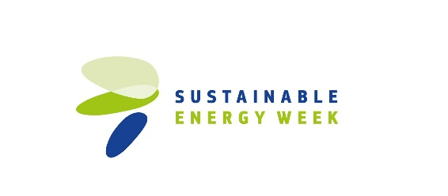
What is it?
A set of visual elements designed for EUSEW including logo and web buttons. You can access the logo using the following link. The different web buttons can be accessed here: 250x250, 300x250 and 728x90.

How to use it?
The visual identity can be used to customise any of your promotional activities or materials related to your EUSEW Energy Day. The logo can be included in emails and printed material for your event, such as attendance sheets, programmes and flyers. The banners and web buttons can be used for your website and respective social media that announce your Energy Day event. You can use the banner or the web buttons to update your cover image on Facebook and Twitter.

Energy Days email signature

What is it?
The email signature “Energy Day Organiser”. You can access it using the following link.

How to use it?
Insert it as a signature in your emails. You can use the signature when emailing invitations to your Energy Day, or in your day-to-day emails in the run-up to your event.

EUSEW News Announcement

What is it?
This text template is aimed at supporting Energy Day organisers in their media outreach activities. It can be adapted to include information about your local event. You can find it here.

How to use it?

You can use it to pique the interest of media outlets or to invite journalists to your event. You can adjust the text according to the purpose and it can be sent via email as part of your media outreach activities.

Some tips:
Map journalists and media channels who work in fields related to clean energy and energy efficiency.

Send the news announcement to journalists to raise the visibility of your Energy Day in your community, country and abroad. Follow up with the journalists personally.

Share your media coverage with the Energy Days Secretariat at energydays@eusew.eu!

Newsletter item on Energy Days
What is it?
This is a short descriptive text with a call for organisers of Energy Days. You can access it here.

How to use it?
When you have a large network of organisations, you can put this text in your newsletters to invite them to follow your example by organising an Energy Day.

EUSEW ppt templates 16:9 & 4:3
What are these?
PowerPoint templates with EUSEW branding (in two different formats). Each includes a slide on Energy Days. The templates can be found here (16:9) and here (4:3).

How to use these?
You can use the templates to give PowerPoint presentations at your Energy Day. You can edit these to suit your needs. You can also ask external presenters to make use of these templates.

EUSEW Editable Poster

What is it?
A poster (for print) with EUSEW branding that you can edit. Follow this link to access it.

How to use it?
You can edit the poster to include the details of your event. You can print and display your poster to promote your event on the day, or you can send it to other interested organisations for them to display.

Social Media Post Templates

What is it?
Templates for social media messages on Facebook, Twitter and LinkedIn that are consistent with the EUSEW brand. You can access the templates here.

How to use it?
You can use the template for social media messages to promote your event and let your followers know that you are part of the EUSEW community online. You can adjust the text in the template by adding details about your event.

Some Tips:
Use the official campaign hashtags and mention the EUSEW accounts when promoting your messages (see below).

Include questions, facts and figures in your tweets to engage viewers.

EUSEW also regularly promotes posts on Facebook and Twitter. Follow EUSEW (EU Sustainable Energy Week on Facebook and @euenergyweek on Twitter) and take an active role by liking, sharing and commenting on the EUSEW posts.

Official campaign hashtags
#EUSEW19 #EnergyDays

Official Twitter account
@euenergyweek

Official Facebook account
EUEnergyWeek

